“Heaven’s Light is Our Guide”
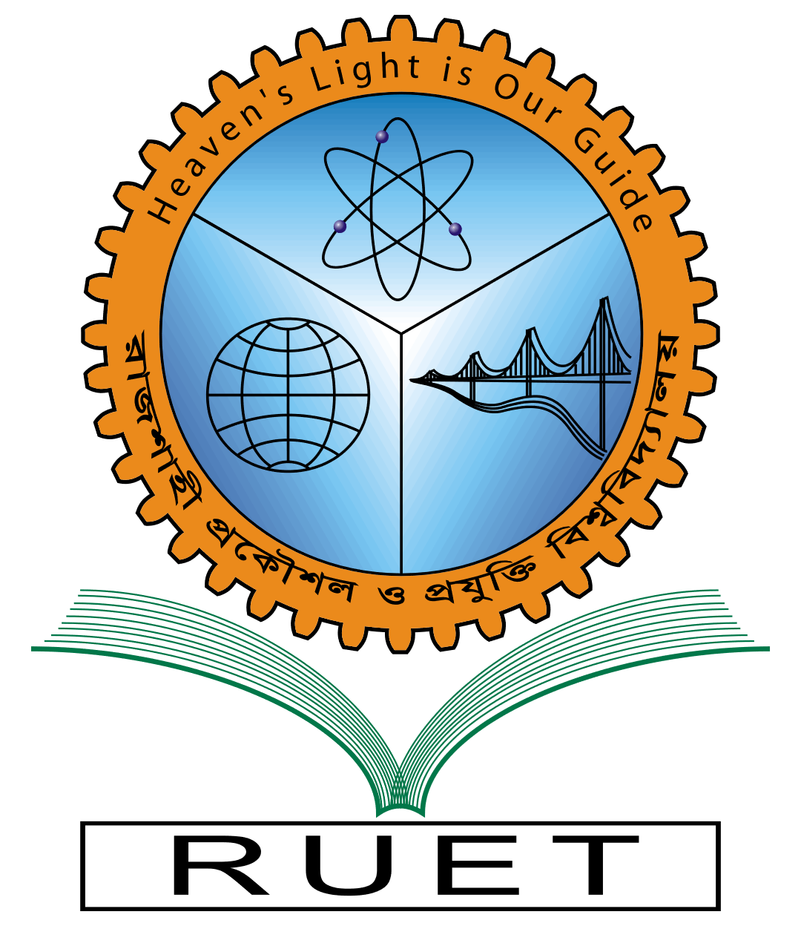
Rajshahi University of Engineering & Technology
Department of Computer Science & Engineering
Lab Report
Course Code: | CSE 3106
Course Name: | Computer Interfacing and Embedded System Sessional
Experiment No: | 01
Experiment Name: | LED Control with STM32 (Blue Pill) Microcontroller
Date of Experiment:
Date of Submission: | 28 May 2024

Submitted By: | Submitted To:
Name: Tonmoy | Md. Nasif Osman Khansur
Section: A | Lecturer
Roll: 2003027 | CSE, RUET
Year: 3rd Year, Odd Semester

